Week 6 OO Design

Software Principles

* Separation of concern
  + Note : Identify different areas of concerns and separate, helps deal with complexity, achieve required engineering quality
  + Example : The interface and application/control logic of use cases concerns are separated from business and data classes objects( whose primary concern is data storage)
* Modularity
  + Separating software into component/modules according to functionality and responsibility.
    - Ignore details of other modules when dealing with a module
    - Cohesion and coupling
      * Cohesion
        + Module understandable as a meaningful unit and components of a module are closely related to one another
        + Modules have interactions with others

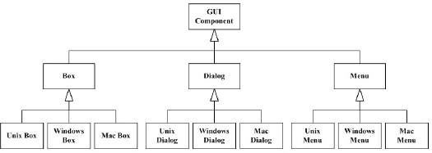

* + - * + Cohesion: a group of clearly defined process that are functionally related. Operation cohesion the degree of an operation achieves a single requirement
        + High Operation cohesion = good design
      * Coupling
        + Modules should exhibit low coupling(Modules have low interaction with each other) understandable separately
        + Strong coupling or High Coupling (Except class inheritance) should be avoided.
        + Interaction coupling, The number os message types an object sends to other objects and the number of parameters passed.

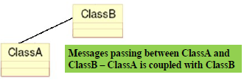

* Abstraction
  + A special case of Separation of concerns
  + Separates the behaviour (What it does) of software components, from there implementation (How it does it).
  + Data Abstraction – the developer and other objects in the system have a abstract view of what data items are.
  + Procedure abstraction – A High level summary of the operations provided. The details and how the methods are coded are ignored.
  + Data Hiding – The developer and other objects in the system have no direct access to the attributes or details of how the attributes are stored.
  + Procedure Hiding – The developer and other objects in the system do not know the detail of how the methods work. The name of the method is public but the implementation is hidden.
* Information Hiding
* Reusability